Enforcement Guidelines

Maritime Safety Queensland

2024

**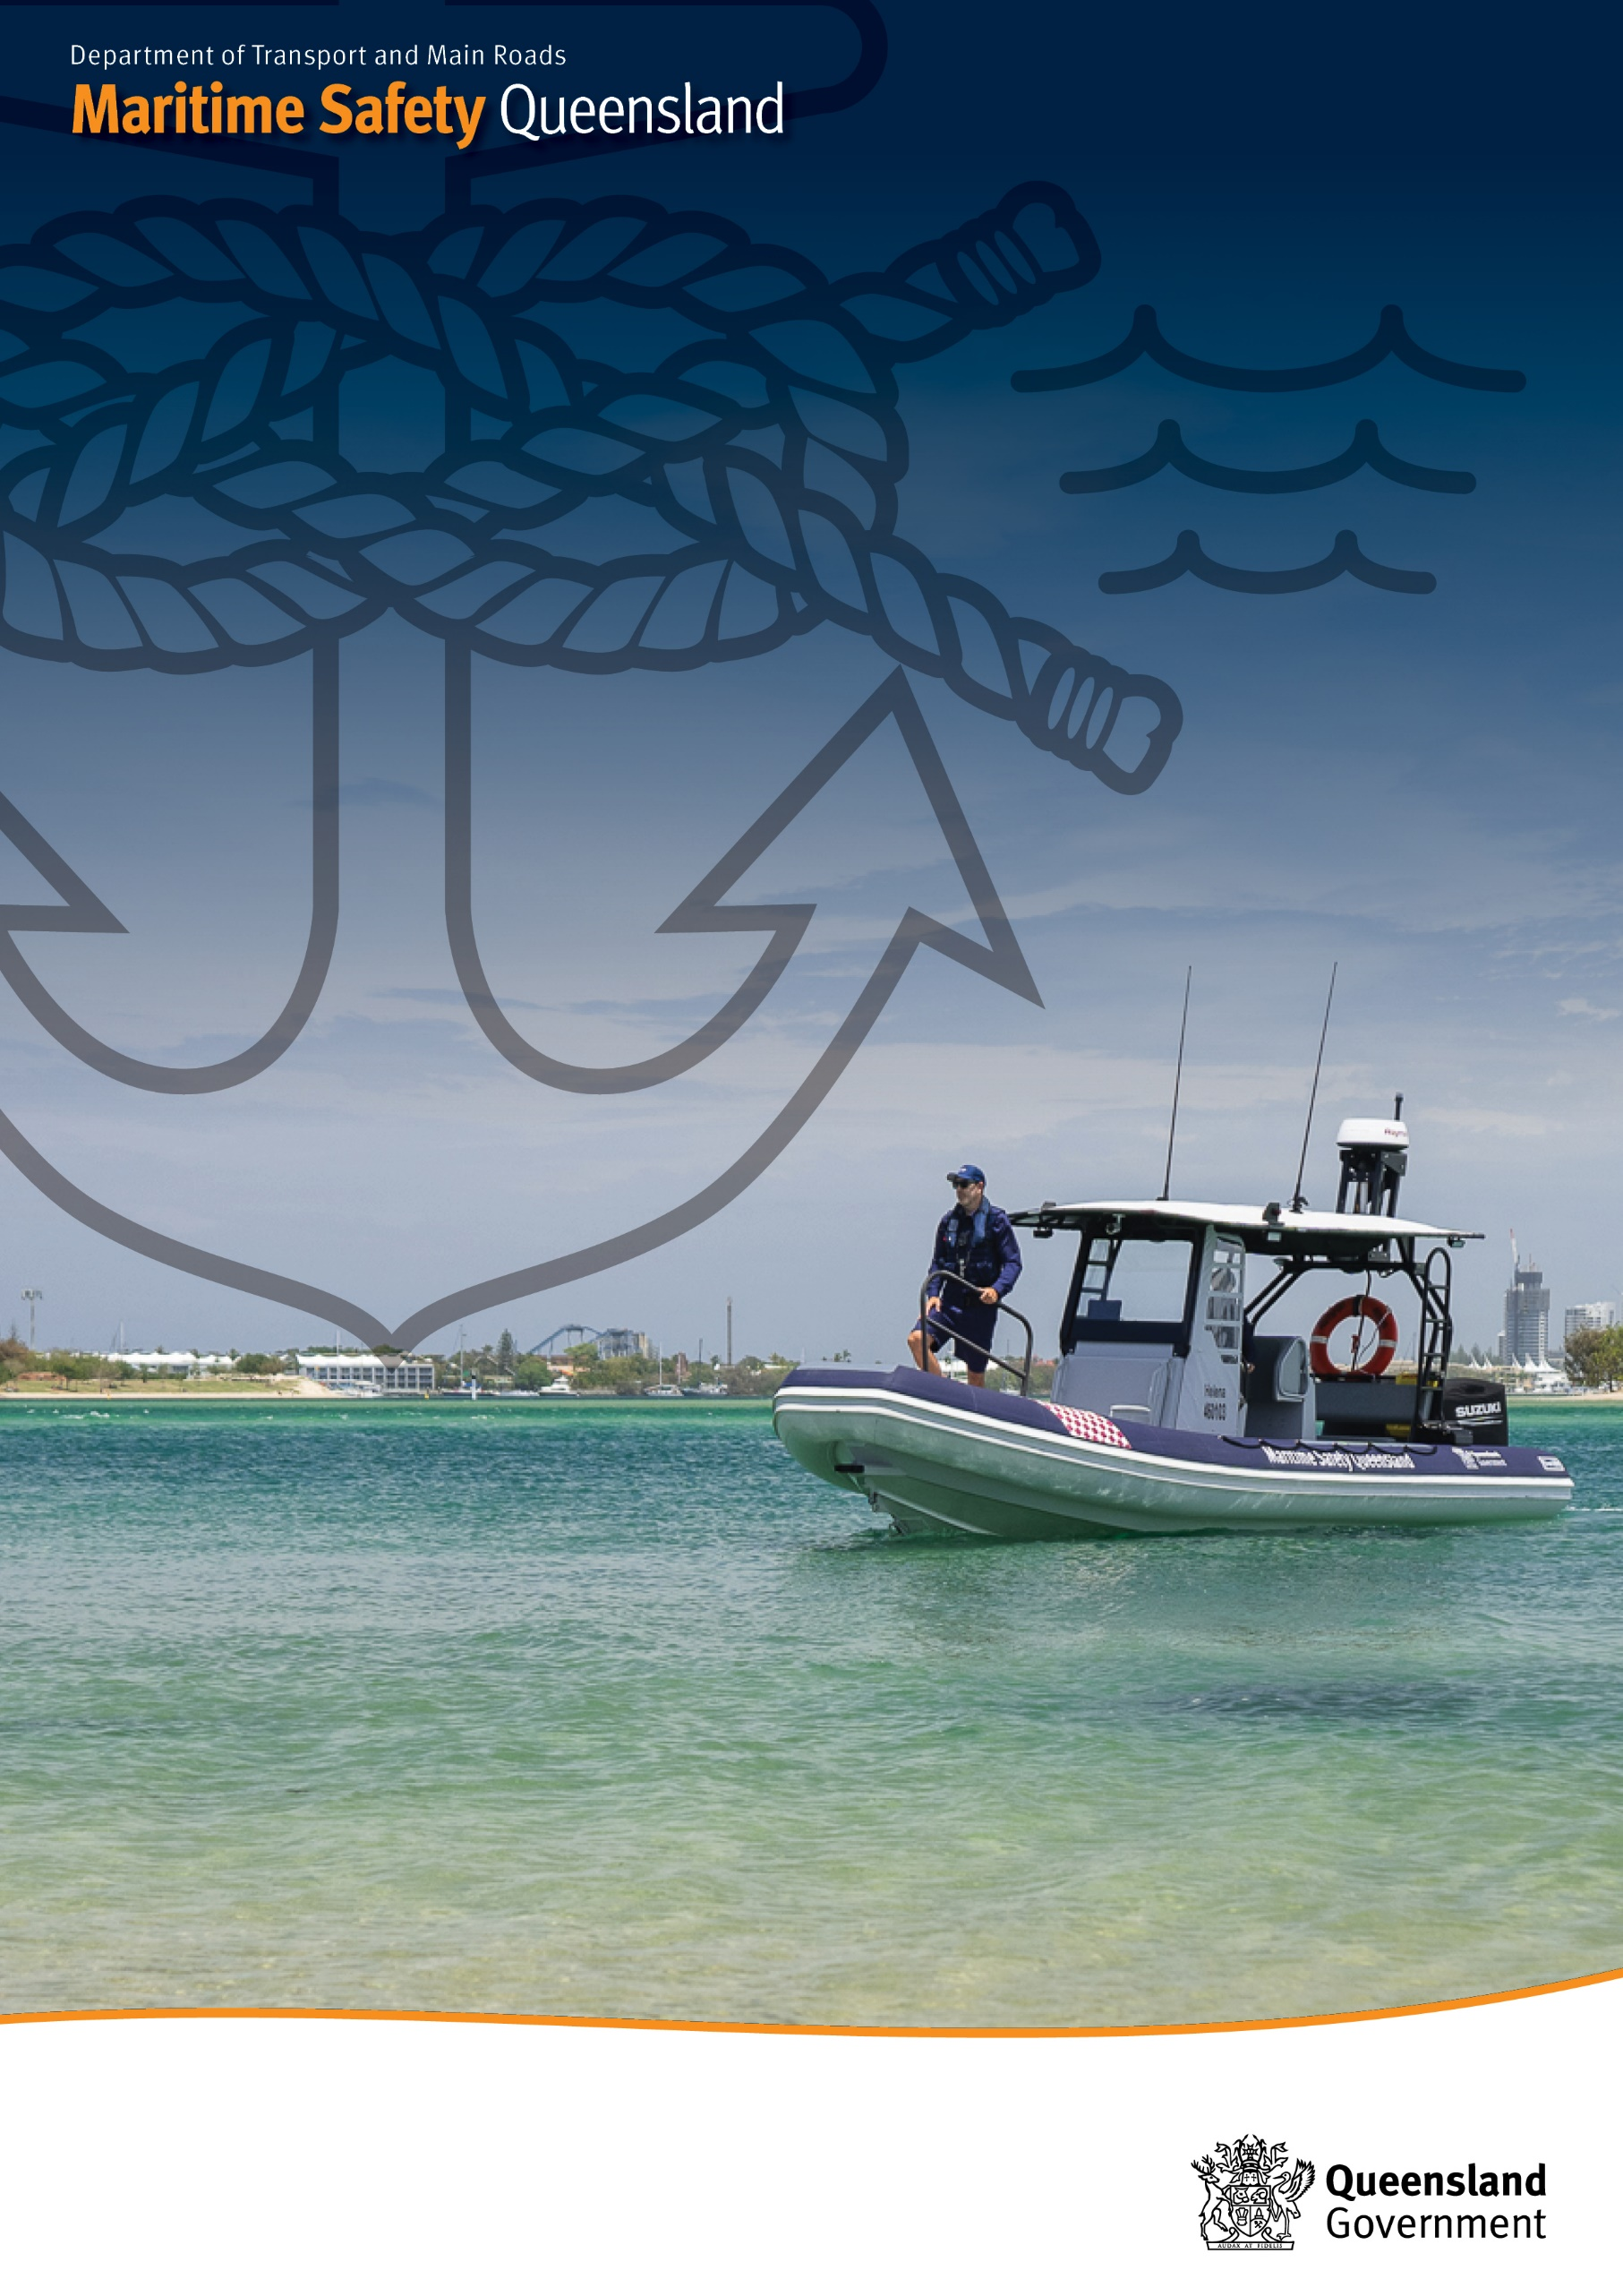**

**Creative Commons information**

© State of Queensland (Department of Transport and Main Roavds) 2017

<http://creativecommons.org.licences/by/4.0/>

This work is licensed under a Creative Commons Attribution 4.0 Licence. You are free to copy, communicate and adapt the work, as long as you attribute the authors.

The Queensland Government supports and encourages the dissemination and exchange of information. However, copyright protects this publication. The State of Queensland has no objection to this material being reproduced, made available online or electronically but only if its recognised as the owner of the copyright and this material remains unaltered.

|  |  |
| --- | --- |
| Interpreter_Symbol | The Queensland Government is committed to providing accessible services to Queenslanders of all cultural and linguistic backgrounds. If you have difficulty understanding this publication and need a translator, please call the Translating and Interpreting Service (TIS National) on 13 14 50 and ask them to telephone the Queensland Department of Transport and Main Roads on 13 74 68. |

Disclaimer: While every care has been taken in preparing this publication, the State of Queensland accepts no responsibility for decisions or actions taken as a result of any data, information, statement or advice, expressed or implied, contained within. To the best of our knowledge, the content was correct at the time of publishing.

Contents

[1. Introduction 1](#_Toc184117987)

[2. MSQ’s Approach 2](#_Toc184117988)

[Enforcement Response 3](#_Toc184117989)

[3. Enforcement Measures 5](#_Toc184117990)

[Marine Cautions 6](#_Toc184117991)

[Marine Infringement Notices 7](#_Toc184117992)

[Directions and Notices 9](#_Toc184117993)

[Enforceable Undertaking 10](#_Toc184117994)

[Suspension or Cancellation of an Authority, Licence or Registration 11](#_Toc184117995)

[Enforcement Orders 13](#_Toc184117996)

[Prosecution 14](#_Toc184117997)

# Introduction

Maritime Safety Queensland (MSQ) has developed these guidelines to provide guidance to staff and regulated users of Queensland’s waterways on the approach that will be taken when addressing non- compliance with State marine legislation.

Legislation forms the basis of a regulation framework to assist MSQ with its task of protecting Queensland’s waterways and the people that use them. The two central pieces of legislation that set the regulatory framework are the:

* + *Transport Operations (Marine Safety) Act 1994 (and Transport Operations (Marine Safety) Regulation 2016)* and;
  + *Transport Operations (Marine Pollution) Act 1995 (and Transport Operations (Marine Pollution) Regulation 2018).*

# MSQ’s Approach

MSQ adopts a risk-based approach to regulating marine safety and ship-sourced pollution in Queensland. We will prioritise compliance and enforcement activities towards high risk areas and where we can achieve the greatest benefits in marine safety and the prevention of ship-sourced pollution.

MSQ is guided by six principles when undertaking its compliance and enforcement role as the regulator for State marine legislation.

**Proportionality**

Compliance efforts will be commensurate to the identified risk. Enforcement measures will be proportional to the level of non-compliance and culpability of the offender.

**Consistency**

Similar circumstances will lead to similar enforcement approaches. Outcomes from enforcement activities should be consistent and predictable.

**Transparency**

Regulations and standards will be developed, promoted and enforced impartially. Information to assist people to understand their responsibilities and what is expected of them will be shared and promoted.

**Accountability**

MSQ will be willing to explain decisions and the conduct and actions of enforcement officers. Avenues of complaint or appeal are available, and decisions are open to public scrutiny.

**Targeted**

Our compliance and enforcement activities will focus on the most risk-generating activities and hazards.

**Responsive**

Compliance and enforcement actions are responsive to circumstances and changing trends. Enforcement action will be timely to maximise the effectiveness of any deterrence and prevent continued non-compliance.

### Enforcement Response

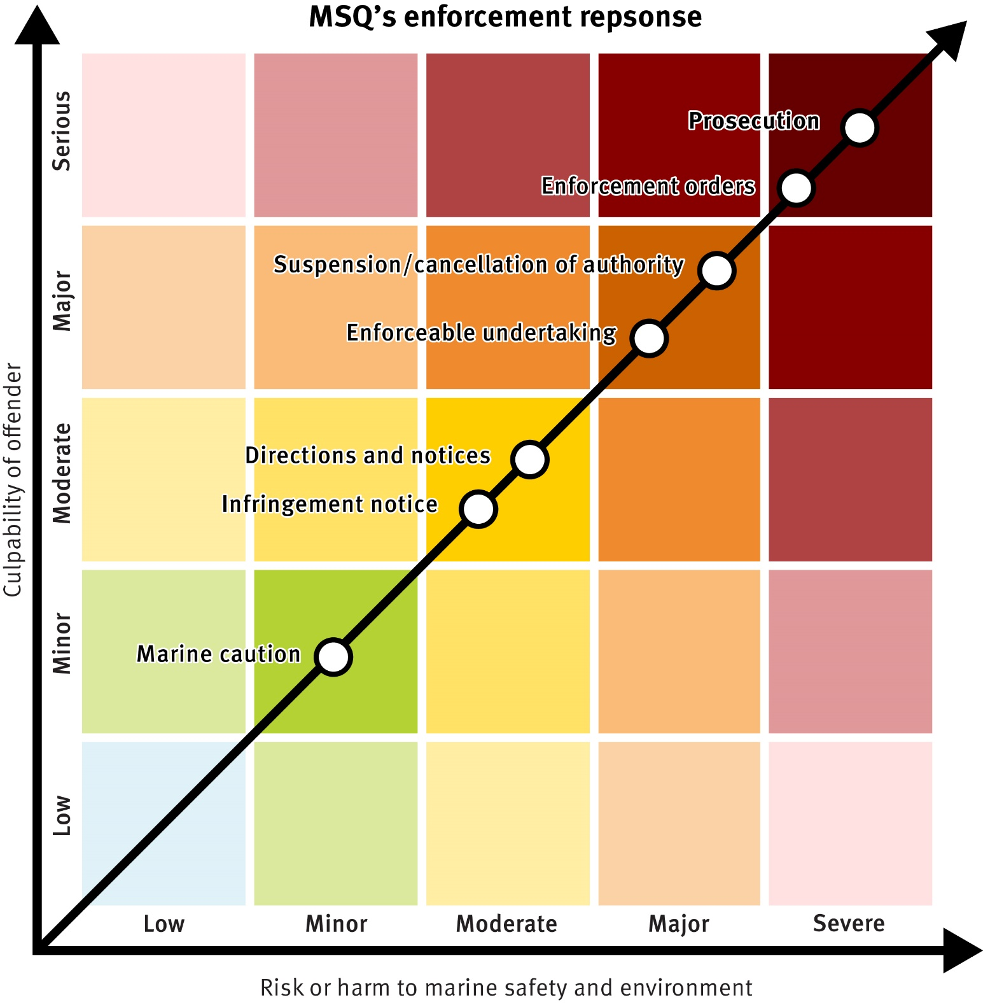

MSQ’s risk-based, responsive enforcement model provides for an escalation of enforcement actions ranging from marine cautions through to prosecution. The model is similar to EPA Victoria’s approach which was developed through an extensive review conducted in 20101. The level of risk associated with non-compliant actions or behaviour is determined by evaluating the actual or potential harm to marine safety or the marine environment and the culpability of the offender. Enforcement responses will be commensurate with the risk.

The criteria in Figure 1 will be used to assist enforcement officers and decision makers in determining risk and culpability. The criteria should be viewed as indicative rather than definitive. Each matter is unique and must be assessed on a case by case basis.

1 Stan Krpan, *Compliance and Enforcement Review: A review of EPA Victoria’s approach* (February 2011), 97.

|  |  |
| --- | --- |
| **Culpability of offender** | **Risk or harm to marine safety and environment** |
| Serious | Severe |
| * Intentional or wilful acts * Past convictions or breaches of similar legislative provisions * Repeated or ongoing non-compliance * Risk was obvious and preventable * Wilful ignorance of standards or directions * which may have prevented or lessened the level of non-compliance | * Permanent or long-term serious environmental harm * Severe impairment to landscapes and recovery may take months * Actual or potential life-threatening harm to safety resulting in death or grievous bodily harm * Loss of ship or serious damage to property |
| Major | Major |
| * Reckless acts * Past enforcement activity or breaches of similar legislative provisions * Regular or repeated non-compliance * Risk was foreseeable and easily preventable * Non-compliance with standards or directions which may have prevented or lessened the level of non-compliance | * Medium to long-term impact or potential impact on the environment * Significant impacts to environment requiring recovery actions * Actual or potentially serious harm to safety requiring hospital admission * Significant damage to a ship or property |
| Moderate | Moderate |
| * Negligent or careless acts * Previous non-compliance of similar legislative provisions * Little regard for a risk that is foreseeable and preventable * Non-compliance may have been prevented by following established standards | * Temporary to medium-term impact or potential impact on the environment * Isolated impacts to environment, recovery may occur naturally * Actual or potential harm to safety requiring medical attention * Moderate damage to a ship or property |
| Minor | Minor |
| * Inadvertent acts * Past isolated non-compliance * Risk was difficult to predict and prevent * Genuine attempt to follow established standards | * Transient impact or potential impact on the environment * Minimal recovery actions required * Low potential harm to safety * Minor damage to ship or property |
| Low | Low |
| * Unavoidable acts * No prior non-compliance * Risk could not be predicted or prevented * Compliant with established standards | * No impact or potential impact on the environment * No recovery actions required * No potential harm to safety * No damage to ship or property |

**Figure 1**

# Enforcement Measures

Maritime legislation provides a range of enforcement measures which can be used in combination, separately or for particular types of non-compliance. MSQ aims to use the most appropriate measure, based on the associated risk, to effectively achieve outcomes that support our goal for safe, clean seas in Queensland:

* + **Zero incidents** will equal **safe movement** of vessels in Queensland’s waters.
  + **Zero casualties** including fatalities or serious injuries, if an incident does occur equals **safe users.**
  + **Zero ship-sourced pollution** incidents will equal **safe environment**.

#### Priority Areas of Enforcement

MSQ will identify priority areas of enforcement for which cautions may not be given. Priority areas of enforcement will change periodically, in consultation with partner enforcement agencies, to reflect current trends and emerging risks. Information on priority areas of enforcement will be published on the MSQ website and promoted through traditional and social media channels. Directions for enforcement officers will be provided through Enforcement Directives.

### Marine Cautions

­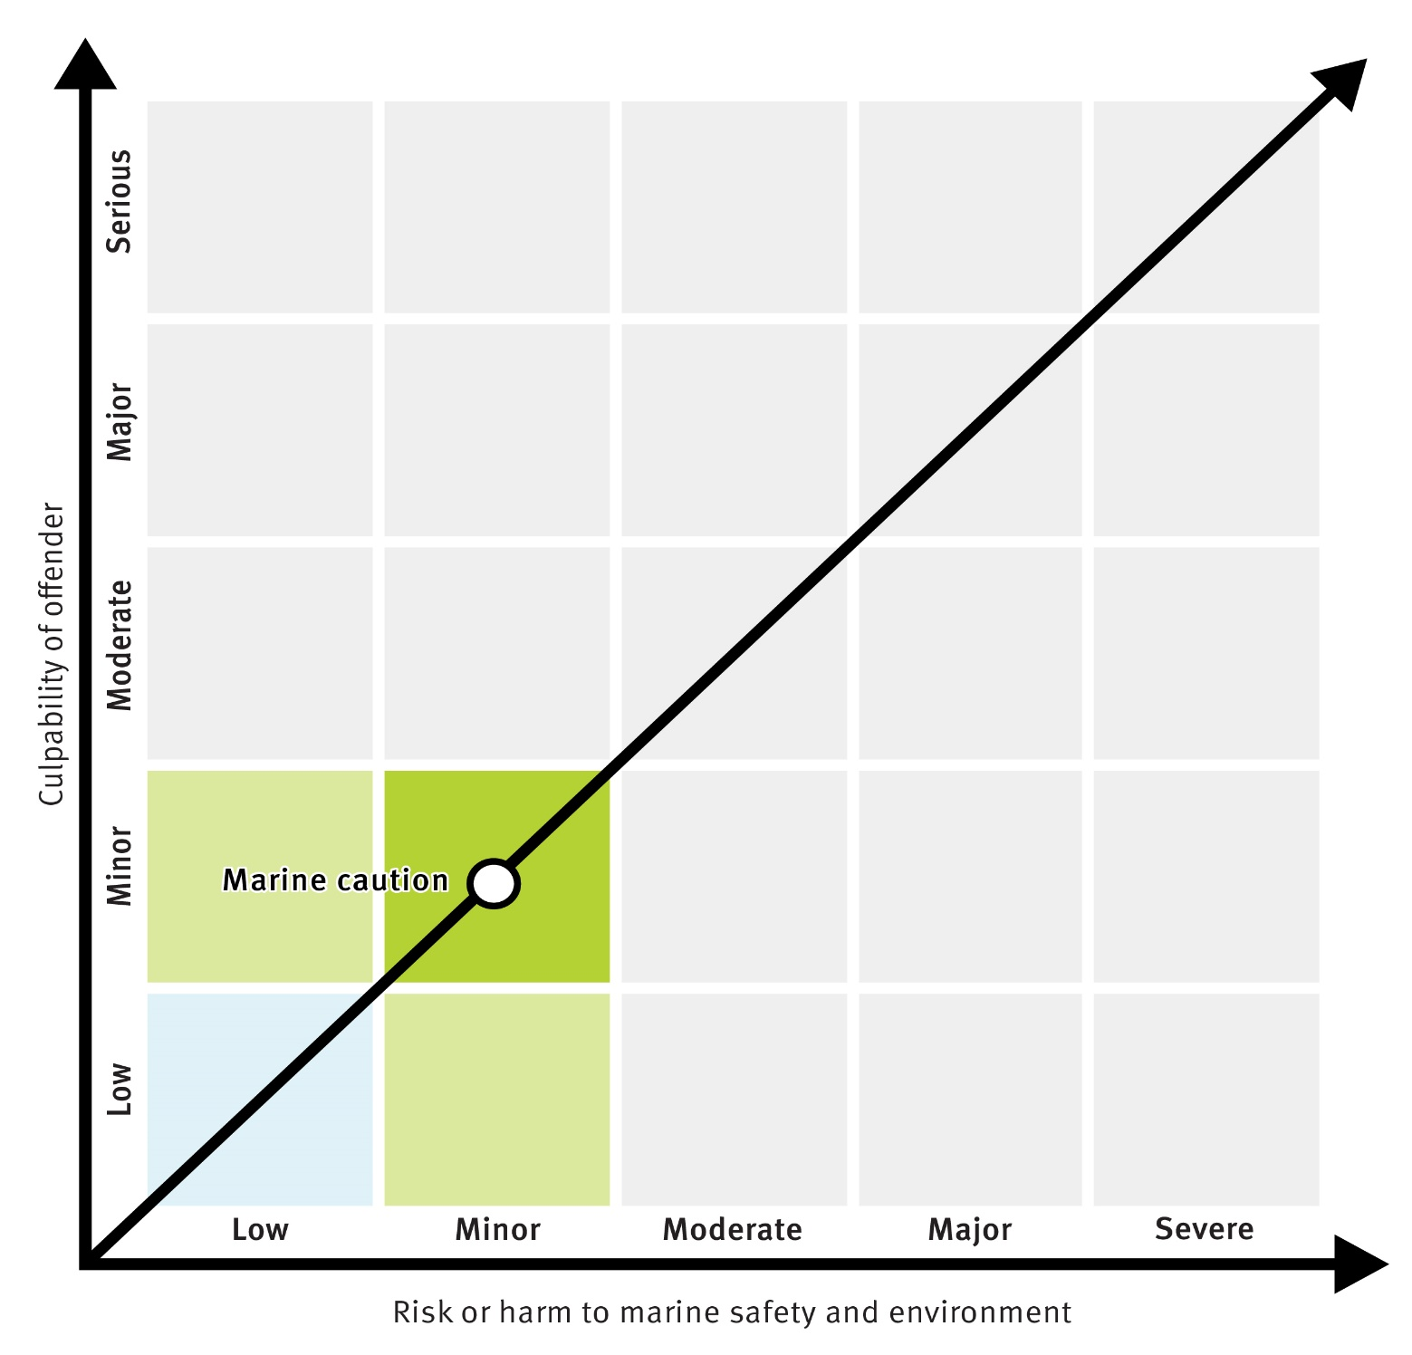

MSQ has a cautioning program for marine safety and pollution offences listed under the *State Penalties Enforcement Regulation 2014.*

When an authorised officer reasonably believes an offence has been committed for which a marine infringement notice (MIN) may be issued, the officer may use discretion to issue a marine caution in lieu of a monetary fine. Some of the matters that will be considered when deciding whether it is appropriate to give a person a caution instead of a penalty notice include2:

1. The offending behaviour did not involve risks to public safety, damage to property or financial loss, or have a significant impact on other members of the public;
2. The offending behaviour is at the lower end of the seriousness scale for that offence;
3. The person did not knowingly or deliberately commit the offence;
4. The person is cooperative and/or complies with a request to stop the offending conduct;
5. It is otherwise reasonable, in all the circumstances of the case, to give the person a caution.

2 Caution Guidelines under the *Fines Act*, The Department of Justice NSW, 31 March 2010

### Marine Infringement Notices

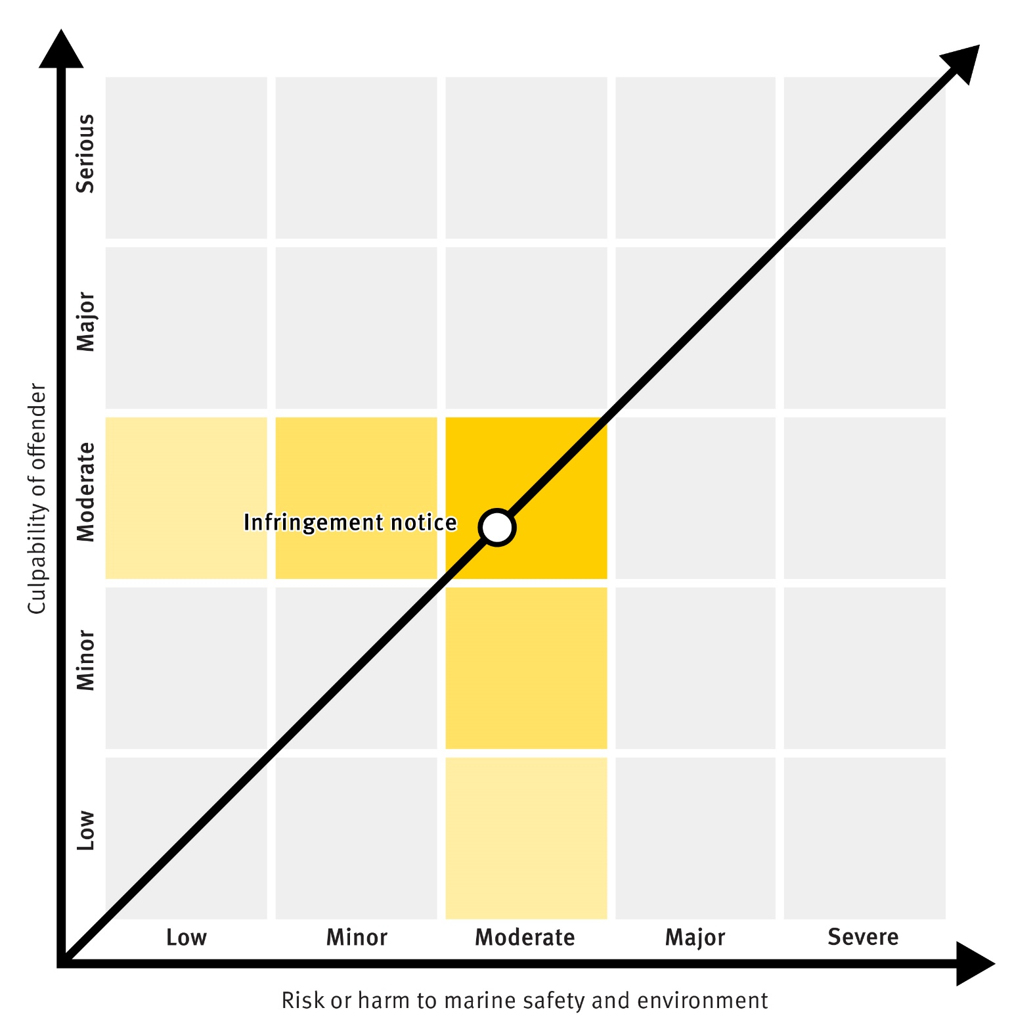

The *State Penalties Enforcement Act 1999 (SPEA)* permits the issue of infringement notices for offences listed in the *State Penalties Enforcement Regulation 2014 (SPER)*.

An infringement notice is similar to an on-the-spot fine, although they can also be sent via the mail. An infringement notice offers the alleged offender an opportunity to deal with the matter by paying an amount specified in the notice rather than through a court proceeding. Infringement notices are an effective tool to address minor and moderate risk offences. Infringement notices allow authorised officers to deal with simple matters without creating extensive administrative work or tying up court time.

After receiving an infringement notice the person

has 28 days to pay the fine or organise a payment plan for fines of $200 or more. A person may also elect to have the matter dealt with by a court. The Election for Court Hearing must be completed on the back of the infringement notice and forwarded to the Department of Transport and Main Roads within the 28 day period from the date of service.

In some instances, the infringement notice is served on the owner of the ship at the time of the offence. The owner is taken to have committed the offence even though the actual offender may have been someone else. If the owner was not operating the ship, the owner has 28 days from the date of service to provide a statutory declaration on the back of the

infringement notice declaring one of the following:

* + Who the operator was;
  + That the ship was disposed of prior to the offence date;
  + That the ship was operated by a person whose name and address the owner has been unable to ascertain after reasonable and diligent enquiries;
  + The ship was stolen or illegally taken at the time of the offence and the matter was reported to a police station.

### Directions and Notices

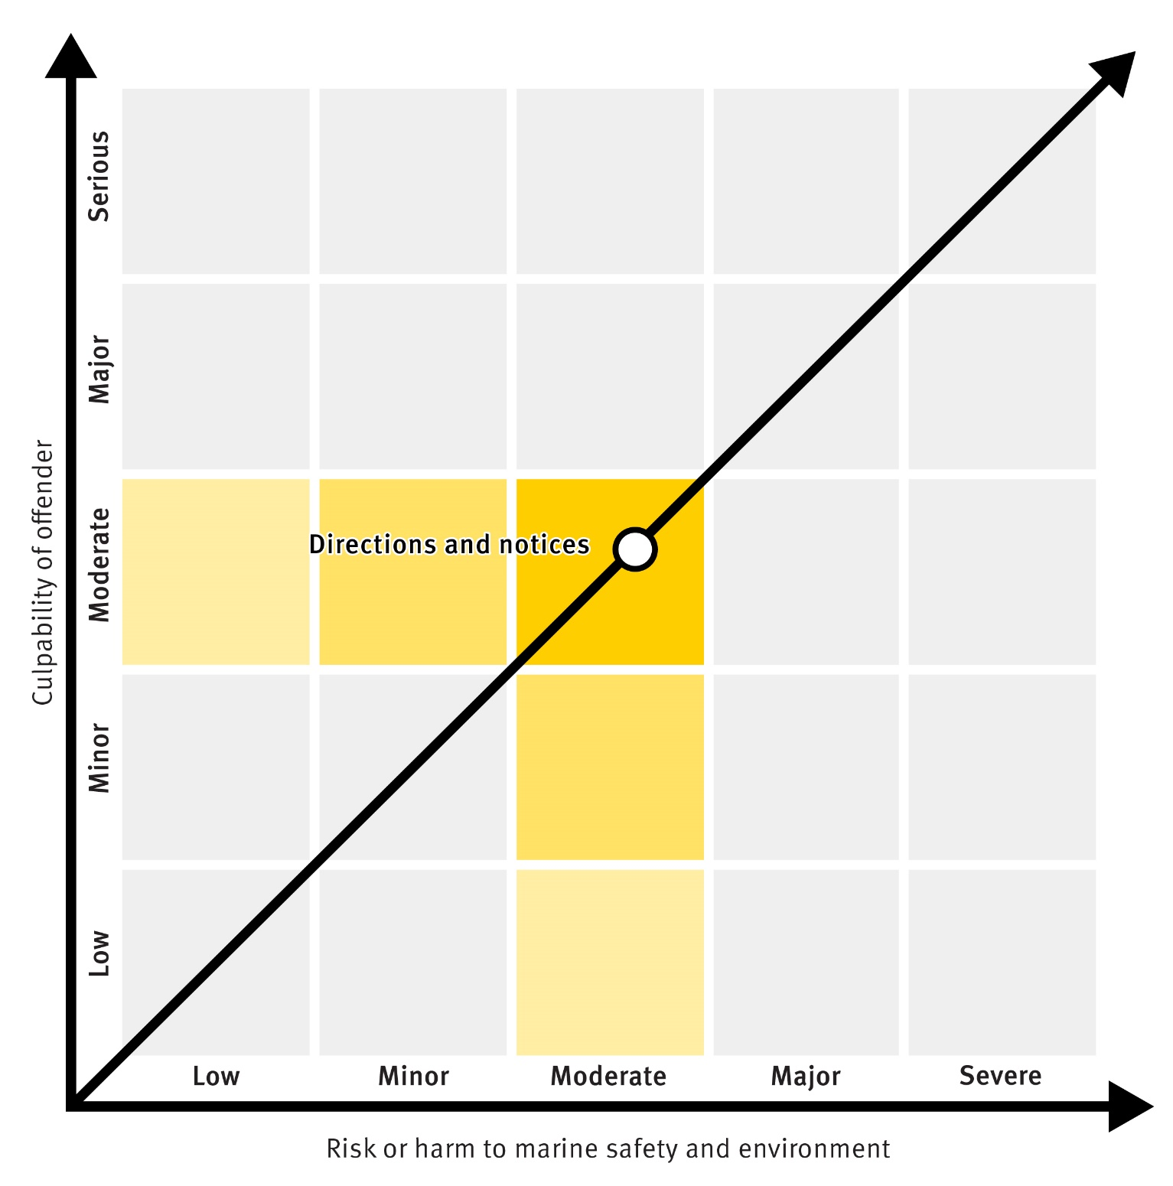

Harbour Masters, Shipping Inspectors and Authorised Officers may direct that various actions are undertaken where there is a risk to marine safety or the marine environment because of ship sourced pollution. Failure to comply with a direction, without reasonable excuse, is an offence.

Directions and notices are administrative actions that allow officers to manage things such as:

* + unsafe and unseaworthy ships;
  + movements and operations of ships;
  + boarding and inspections of ships;
  + pollution discharges and ships that are likely to discharge;
  + safe navigation;
  + contraventions of licensing and registration requirements.

A person whose interests are affected by a direction or notice can seek a review by the General Manager MSQ. If a reviewed decision is not the decision sought by an applicant, that applicant may apply for a review of the reviewed decision as provided under the *Queensland Civil and Administrative Tribunal Act 2009*.

### Enforceable Undertaking

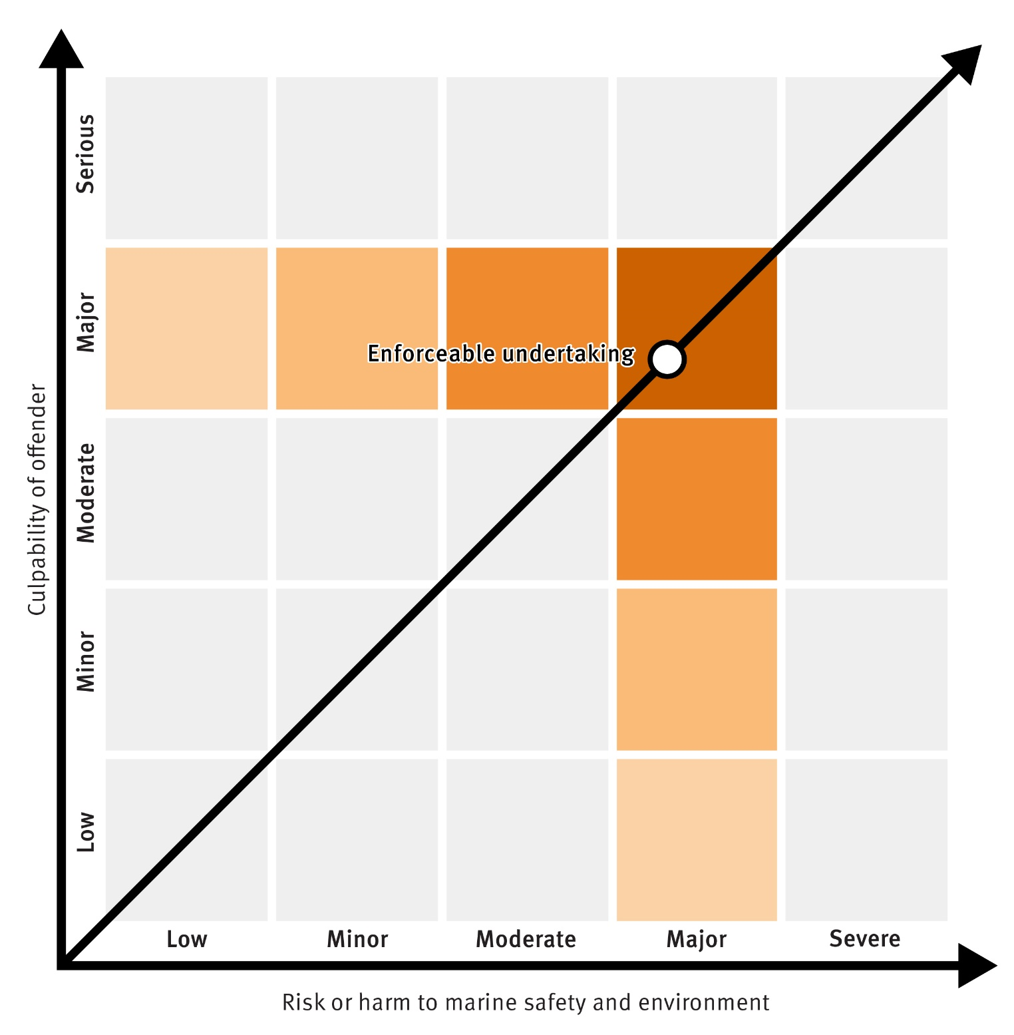

An enforceable undertaking operates as an alternative to a court-imposed sanction for an alleged act or omission that contravenes marine safety or marine pollution legislation. The enforceable undertaking is a legally binding agreement between MSQ and the person proposing the undertaking. MSQ may accept an undertaking that the person will not commit, continue to commit or repeat the act or omission. The undertaking may also provide for other actions to remedy a contravention and reduce the risk of the contravention happening again.

If MSQ reasonably believes that a person has contravened or will contravene a term of the undertaking, MSQ may apply to the District Court for an enforcement order (see below).

### Suspension or Cancellation of an Authority, Licence or Registration

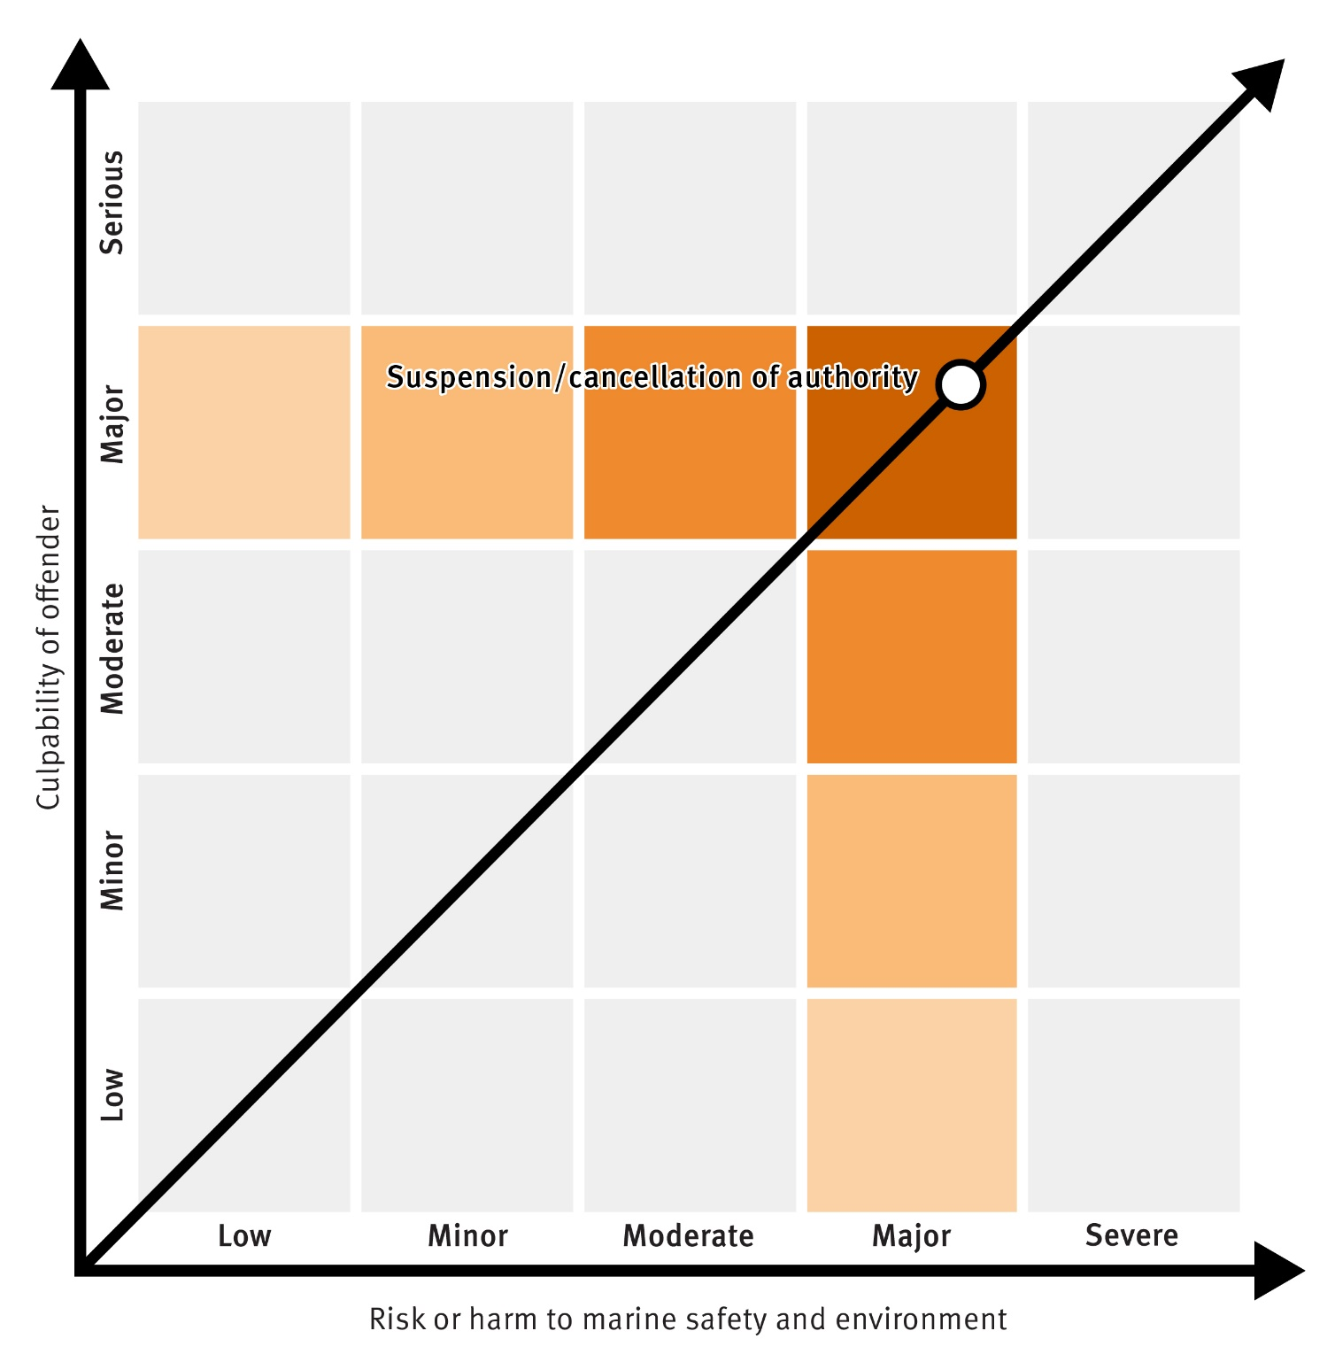

Approvals, authorities, licenses or registrations can be suspended or cancelled under certain circumstances including;

* + where a fee has not been paid;
  + a condition has not been complied with;
  + misleading or false information has been provided;
  + the holder has contravened marine safety or marine pollution legislation; or
  + it is in the interest of marine safety or pollution prevention.

If MSQ considers grounds exist to suspend or cancel an approval, authority, licence or registration, MSQ will provide a written notice outlining:

1. the proposed action;
2. the grounds for the proposed action;
3. an outline of the facts and circumstances forming the basis for the grounds;
4. if the proposed action is suspension – the proposed term of suspension.

The holder of the approval, authority, licence or registration has 30 days to provide written representations showing cause why the proposed action should not be taken. MSQ will consider the written representations and will advise the holder by written notice of the decision within 14 days of making the decision.

A person whose interests are affected by a decision can seek a review by the General Manager MSQ. If a reviewed decision is not the decision sought by an applicant, that applicant may apply for a review of the reviewed decision as provided under the *Queensland Civil and Administrative Tribunal Act 2009*.

### Enforcement Orders

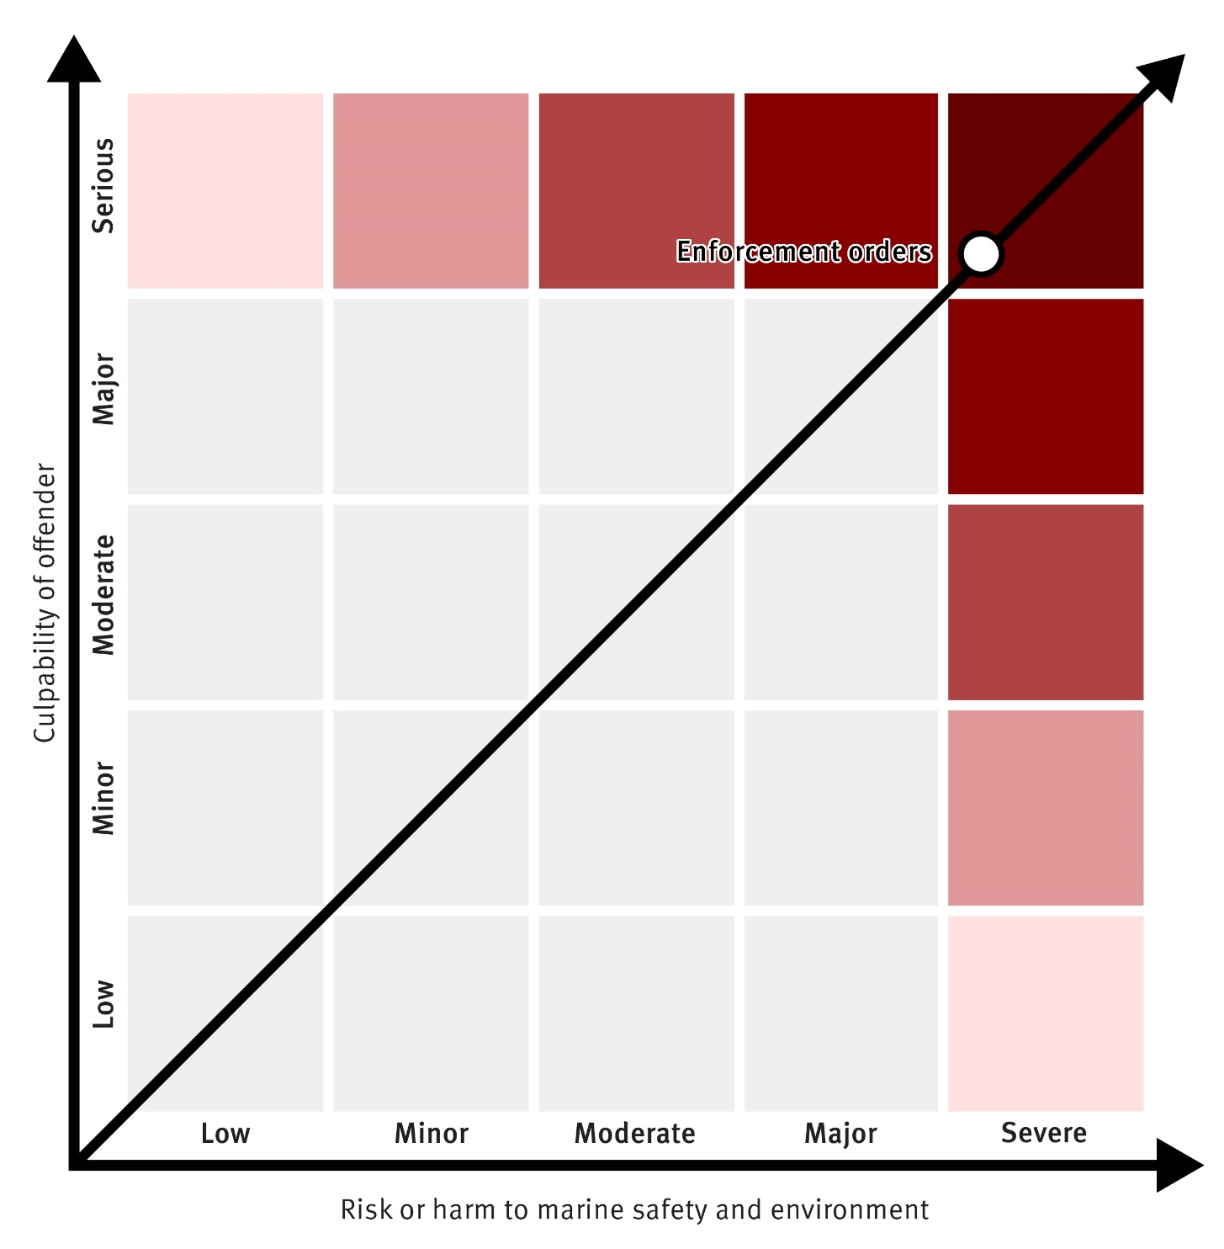

MSQ can seek an enforcement order from the District Court if:

* + a notice offence has been committed or, unless an enforcement order is made, will be committed;
  + an enforceable undertaking has been contravened or, unless an enforcement order is made, will be contravened.

Examples of notice offences include; not complying with a Harbour Master or Shipping Inspector direction and not complying with the direction of an Authorised Officer who requires urgent action to prevent or minimise the discharge of a pollutant into coastal waters. Enforcement orders may be sought in addition to prosecution for the notice offence.

An enforcement order may direct a person to do one or more of the following:

1. to stop the activity that constitutes, or will constitute, a notice offence or a contravention of the Undertaking;
2. not to start an activity that will constitute a notice offence or a contravention of the Undertaking;
3. to do anything required to stop committing a notice offence, or a contravention of the Undertaking including, for example, requiring the repair, demolition or removal of a ship or a part of a ship.

MSQ may also seek a security bond and further orders to remedy the incident and if necessary, take authorised action and recover costs in doing so.

### Prosecution

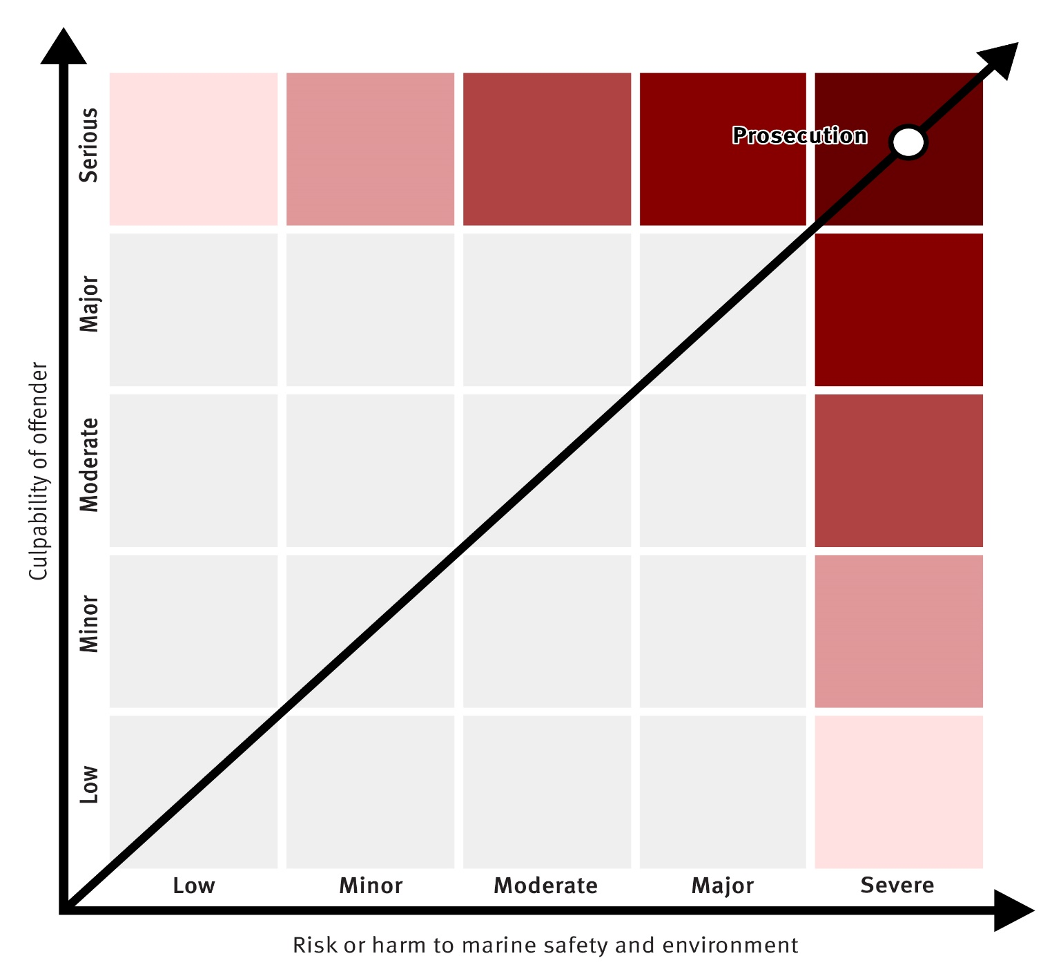

MSQ prosecutes marine safety and marine pollution offences that are serious in terms of consequence, risk and aggravating circumstances. In deciding whether to prosecute, MSQ adopts the policies of the Prosecution Services Unit at the Department of Transport and Main Roads.

The power of the State is to be used for the public good and in the public interest, and not as a means of oppression, even in litigation. However, the community also expects the State to properly use taxpayers’ money, and in particular, not to spend it without due cause and due process. This means that demands on the State for compensation for injury or damages should be carefully scrutinised to ensure that they are

justified.3 MSQ will adopt the model litigant principles issued at the direction of Cabinet and published by the Department of Justice and Attorney-General in the conduct of litigation and prosecutions, as far as they are relevant.

1. **Principles of fairness:**
   * acting consistently in the handling of claims and litigation;
   * dealing with claims promptly and not causing unnecessary delay in the handling of claims and litigation;
   * endeavouring to avoid, prevent and limit the scope of legal proceedings wherever possible, including by giving consideration in all cases to alternative dispute resolution before initiating legal proceedings and by participating in alternative dispute resolution processes where appropriate;
   * where it is not possible to avoid litigation, keeping the costs of litigation to a minimum;
   * paying legitimate claims without litigation, including making partial settlements of claims, or interim payments, where liability has been established and it is clear that the State’s liability is at least as much as the amount to be paid;
   * not seeking to take advantage of an impecunious opponent;
   * not contesting matters which it accepts as correct, in particular by:
     + not requiring a party to prove a matter which the State knows to be true
     + not relying on purely technical defences where the State will suffer no prejudice by not doing so
     + not contesting liability if the State knows that the dispute is really about quantum
   * not instituting and pursuing appeals unless the State believes that it has reasonable prospects for success, or the appeal is otherwise justified in the public interest.
2. **Principles of firmness:**
   * appropriately testing all claims;
   * contesting all spurious or vexatious claims;
   * claiming legal professional privilege where appropriate;
   * claiming public interest immunity to protect confidential information such as Cabinet papers in appropriate cases;
   * seeking security for costs where appropriate and pursuing costs when it is successful in litigation, which will assist in deterring vexatious proceedings from being instituted against it;

3 Department of Justice and Attorney General, *Model Litigant Principles,* March 2019, [https://www.justice.qld.gov.au/justice-services/legal-services-coordination-unit/legal-service-](https://www.justice.qld.gov.au/justice-services/legal-services-coordination-unit/legal-service-directions-and-guidelines/model-litigant-principles) [directions-and-guidelines/model-litigant-principles](https://www.justice.qld.gov.au/justice-services/legal-services-coordination-unit/legal-service-directions-and-guidelines/model-litigant-principles)

* + not seeking to take advantage of an impecunious opponent;
  + relying on available statutes of limitation, which have been enacted to protect a defendant from unfair prejudice;
  + acting properly to protect the State’s interests.

1. **Alternative dispute resolution**
   * The State is only to start court proceedings if it has considered other methods of dispute resolution (for example, alternative dispute resolution or settlement negotiations).
   * When participating in alternative dispute resolution, the State must ensure that its representatives:
2. participate fully and effectively, and
3. have authority to settle the matter so as to facilitate appropriate and timely resolution of a dispute.

#### Court Orders

Upon conviction of an offence, in addition or instead of a monetary penalty, the court may make an order. The order may be about compensation of State expenses or other actions such as;

1. to take a stated action to rehabilitate or restore Queensland’s marine and coastal environment;
2. an education campaign to promote compliance with the Act;
3. a public apology;
4. to operate a ship in a particular way;
5. to repair, modify, or replace a ship or part of a ship;
6. to start or stop a stated activity in relation to a ship;
7. not to own or operate a ship unless the General Manager has given written consent for the ownership or operation; or
8. to comply with another order the court considers appropriate.