Backing Queensland Maritime Jobs
M ar i t im e I ndust r y Pr esent at i on Kell Dillon, G ener a l M anager M ar i t im e Saf et y Q ueensland

11 December 2023

Acknowledgement of Traditional Owners and Elders
'Travelling' by Gilimbaa
2
I’d like to begin by acknowledging the Traditional Owners of the land where we
meet today. I would also like to pay my respects to the Elders both past and present.

I also extend that respect to the Aboriginal and Torres Strait Islander people here today.

Department of Transport and Main Roads

Agenda

- Background
- Coastal Shipping Grant Program round two
- Objectives
- Target groups
- Key concepts
- Eligibility criteria
- Assessment criteria
- Assessment process and timeline

Department of Transport and Main Roads

4

Background

  - 2019 – Transport and Public Works Committee publishes report on sustainable intrastate shipping.

  - 2020 – Premier announces $21m over two years for the creation of QLD maritime jobs.

  - 2021 – Maritime Safety Queensland (MSQ) seeks submissions on QLD maritime industry revitalisation and job creation.

  - 2022 – MSQ develops grant programs and partners with industry to deliver.

  - 2023 – Maritime Training and Employment Grants and two Coastal Shipping Grants awarded.

Department of Transport and Main Roads

5

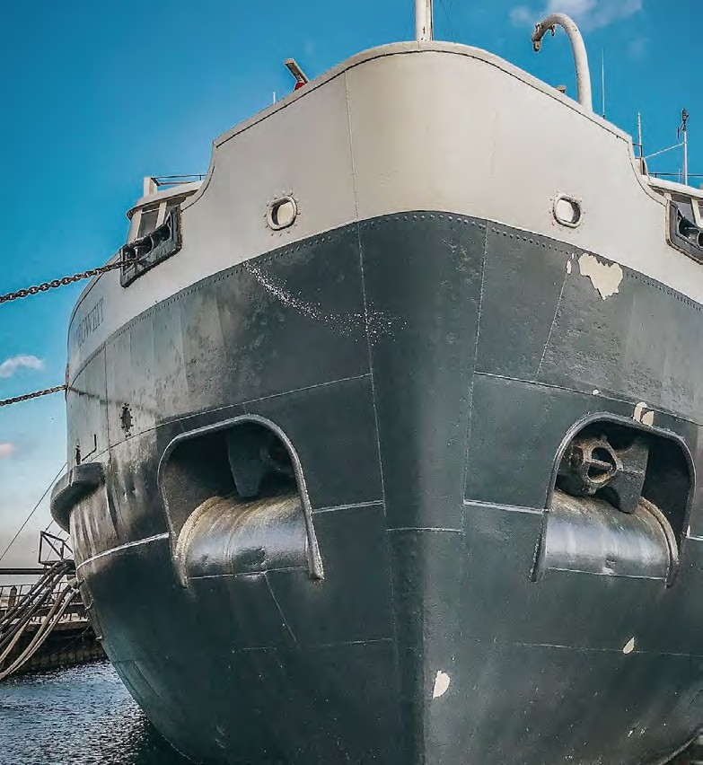
Coastal Shipping Grant program Objectives

The objectives of the Coastal Shipping Grant Program round 2
(CSGP2) are to:

  - establish or strengthen coastal shipping services along the Queensland coast through a Regulated Australian Vessels (RAV) service

  - create sustainable local jobs, incorporating training towards a qualification that aligns with the International Convention on Standards of Training, Certification and Watchkeeping (STCW) 1978

  - provide training, career advancement opportunities and
qualifying sea time experience for local seafarers.

Through the assessment criterion, applicants must address how they will achieve these objectives.
Photo credit: Antonio Janeski, Unsplash.

6

Department of Transport and Main Roads

CSGP2 – Indicative grant applicant groups
The indicative grant applicant groups are:

  - Coastal shippers – commercial entities who are already in the business of shipping goods along the coast of Queensland and wish to expand their route operations.

  - RAV operators – as defined under section 15 of the
Navigation Act 2012.

  - Shipping companies that wish to introduce a dedicated coastal shipping service predominantly along the coast of Queensland.

Photo credit: Jen Theodore, Unsplash.

Department of Transport and Main Roads

7

CSGP2 – Assessment criteria 1

Criterion 1 – Approach to delivering the coastal shipping service, including ability, experience and capability.
Applicants should demonstrate this through:
  - shipping history and experience, particuarly in the provision of coastal shipping services
  - a regular trading schedule, including delay mitigation strategies
  - vessel specifications and characteristics, including crewing arrangements
  - indicative timeframes for implementation and delivery of the proposed coastal shipping service
  - identification of any landside infrastructure required
  - details of relevant maritime safety management and emergency response systems
  - details of any litigation, or governmental or regulatory action pending against the applicant
  - details of how the applicant makes ethical decisions around finance/procurement, industrial relations, and the environment.

Department of Transport and Main Roads

8

CSGP2 – Assessment criteria 2

Criterion 2 – Local benefits from proposed coastal
shipping service.
Applicants should demonstrate this through:
  - existence, or proposed establishment, of an organisation-
level presence in Queensland
  - use of local workforces and a commitment to maintenance docking in Queensland
  - use of local sub-contractors if required
  - details of the new jobs created and where the staff will be
domiciled
  - any other relevant local benefits.

Photo credit: Elias, Unsplash.

Department of Transport and Main Roads

9

CSGP2 – Assessment criteria 3

Criterion 3 – Sustainability of the coastal shipping service.
Applicants should demonstrate this through:
- the forecasted market demand and revenue for the first two years
- details of a cargo attraction strategy, including a freight
analysis
- details of arrangements with service providers such as ports and stevedores
- estimates of freight or cargo to be carried by the
proposed coastal shipping service.

Photo credit: Will Turner, Unsplash.

Department of Transport and Main Roads

10

CSGP2 – Assessment criteria 4

Criterion 4 – Approach to recruitment and training.

Applicants should demonstrate this through details of:
- the proposed approach to incorporate STCW AMSA approved traineeships and cadetships, and integrated ratings and engineer class 3 certifications in the coastal shipping operating model
- any qualifications being funded that target highly sought after skill areas
- any commitment to continue STCW AMSA approved traineeships and cadetships and integrated ratings and engineer class 3 beyond the grant period
- any commitment to any diverse and inclusive employment strategies.

Department of Transport and Main Roads

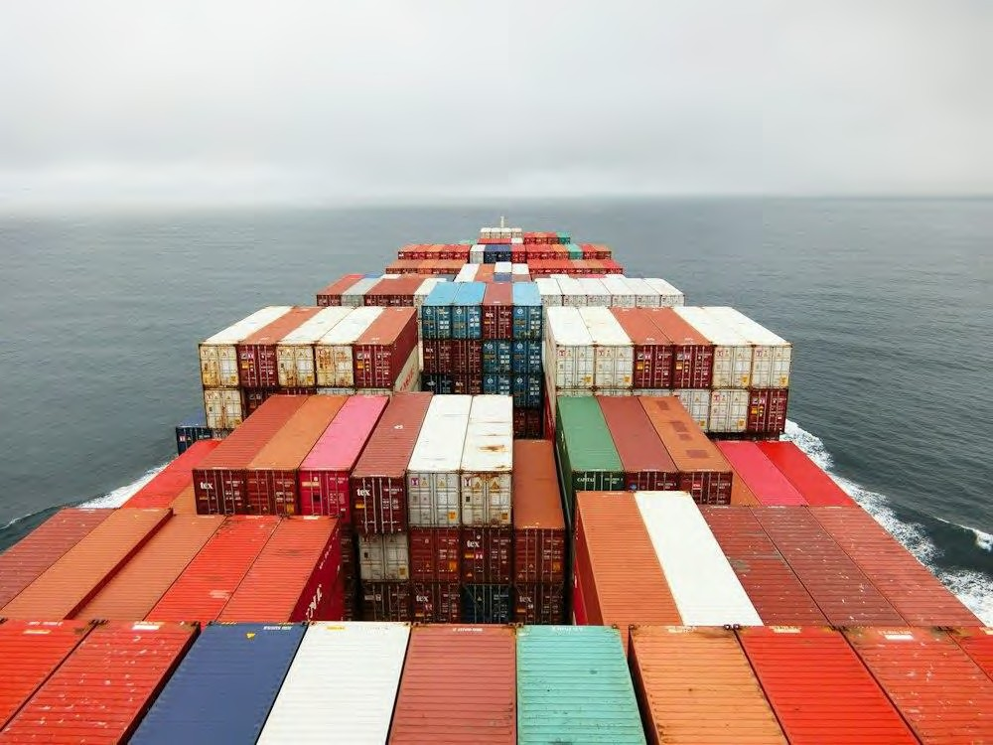
Photo credit: Rinson Chory, Unsplash.

11

CSGP2 – Assessment criteria 5

Criterion 5 – Financial soundness of the applicant and funding requirements.

Applicants should demonstrate this through:
- trading history, revenue, and financial position
- the total and annual quantum of grant assistance requested
- the proposed frequency and timing of grant payments and
milestones
- how the grant assistance is proposed to be expended.

Photo credit: OSG Containers, Unsplash.

Department of Transport and Main Roads

12

CSGP2 – Assessment process and timeline
Please ensure your application is complete.

Applications will be assessed on the information you provide against each assessment criterion.
There will not be any other opportunities to provide supplementary information.

Probity: The Grants programme will be governed by usual QLD Government Probity Rules of;

- Confidential treatment of all Grant and Application information; and
- reporting and management of all conflicts of interest.

Timeline:

- Application closing date – 9 February 2024

- Panel assessment and moderation – February/March 2024

13

Department of Transport and Main Roads

Thank you and stay connected

www. t m r. q l d. gov. au

TMRQld @TMRQld TMRQld Department of Transport and Main Roads

